Living Systems Lab
Overview

Time: 2 hours
Group Size: Up to 45 participants (10-15 students per group)
Grade Levels: 4th – 6th grade
Location: At Sea, Surf Science, CCSI Lab

PROGRAM DESCRIPTION

Teachers can book the Living Systems Lab as a stand-alone program or in combination with the Living Systems Cruise. This program explores the interactions between marine organisms and their ecosystems. In the lab, students will investigate food chains, life cycles, habitats, adaptations, organ systems, and abiotic factors during the four stations. If their program includes a cruise aboard the R/V Sea Explorer, students will examine benthic and pelagic habitats by deploying oceanographic sampling equipment to collect a variety of marine specimens (plankton and mud).

INTRODUCTION

If the group is even a few minutes late it must be shortened. Stations should start no more than 15 minutes after the program start time, so shorten introduction as needed. If they are more than 15 minutes late in arriving, you will need to do this in 5 minutes and shorten stations as required to finish on time. You may even need to divide groups right away and do your own brief introduction with your group.

While one instructor is giving the intro, another instructor needs to group up the chaperones and give a chaperone talk.

Introduction:
Welcome to the Ocean Institute. Introduce self and instructors.
“In this program we are going to explore different systems in the ocean and how they connect. What is a system? (guide them to talk about all parts working together for a function). What does an ecosystem need to function? (Answers will vary). Ecosystems are composed of biotic and abiotic factors. (If time, discuss what these two terms mean. Otherwise, do it at the water quality station). Life cycles and food chains are also systems. Would they work without all of their parts?”
Briefly introduce the four stations and let students know they will be broken up into the appropriate number of groups.
Go over expectations for behavior and safety. No running. Stay with your group. No tapping on the tanks. No flash photography.

Chaperone Talk:
Welcome to the Ocean Institute! Thank you for coming and giving your time so your students may have this experience.
Give a brief description of the program, timing, and rotations (ex. During this two hour living systems lab, students will move through four 25 minute stations with their group, each focusing on a different aspect of systems in the ocean and how organisms are adapted to their habitats).
Role of the chaperones:
- Our labs are inquiry-based learning stations meant to challenge and inspire the students, so we ask that you take a step back and allow them to fully engage in all of the stations.
- Please stay with the group you begin with and help the students focus on their work. Please assist with any behavioral management issues.
- Your instructor may ask you to supervise the students in the event they need to step away or prepare lab materials, so please be prepared to step in.
- Please help the instructor by taking any students to the bathroom.
- Pictures of students should be candid so as not to distract from activities.
Breaking into Groups:
The instructor that talked to the teacher should give the student count and any information on groups to the instructor doing the introduction. If they have grouped in advance, the teacher will want to use them. If they have not, it is best if the teacher will just let you count off students, so no time is wasted. Do not do a 1- 2- 3 count, just quickly count off the number of students you need without looking like you are picking individual students out. Try to take a mix of both boys and girls. Make sure to count the number of students you have when you get to the first station and that you have the right number.

FOUR STATIONS

1. Fish Dissection Station:
Students will explore the external anatomy of a mackerel. They will use their observations to generate hypotheses about how mackerels survive, where they live, and what they eat. They will then dissect the fish in order to explore the internal digestive system and test their hypothesis. If time allows, students can continue dissection with the respiratory and circulatory systems, addressing the animal’s need for dissolved oxygen.

2. Water Quality Station:
Students test and record the non-living (abiotic) factors including pH, temperature, salinity, and dissolved oxygen of four different water samples. Based on the measured data they will determine which fish could live in their given water sample. The abiotic factors of each environment influence the species that live in the habitat.

3. Habitats and Adaptations Station:
Students will investigate the relationship between environment and physical characteristics in this station. Using our tank farm and their field guides, they will explore different organisms and their defense/feeding strategies. The students will then pick a habitat for that organism based on the characteristics they are observing.

4. Life Cycles and Food Web Station:
Students will follow the transfer of energy from its abiotic energy source (the sun) through a food chain that begins with phytoplankton and ends with decomposers. Students will explore the adaptations of adult jellies to their physical environment in the ocean and examine the adult jellies’ role in the food chain. Phytoplankton, brine shrimp (zooplankton) and the stages of development of the jellies will be studied under the microscope to determine their part in the food chain. Students will be investigating different life cycles and how the various stages of each life cycle have a different role to play in the food chain.

SCHEDULE/LOGISTICS

Perfect Timing Example: 25 Minute Stations
9:30 – 9:40 Introduction
9:40 – 10:05 Station 1
10:05 – 10:30 Station 2
10:30 – 10:55 Station 3
10:55 – 11:20 Station 4
- Program Set Up:
- If it is the first program of your day, arrive at scheduled time to set-up before the school arrives. Read challenge sheets for equipment and preparation needed for each station. Make sure to get the fish out first, they take time to thaw. If there are two Living Systems programs at the same time, one will be run in Sahm. Make sure to return any equipment borrowed from At Sea when the program is finished.
- Bring Them In:
- Decide who will do the introduction during set up time; it is important to start the program on time.
- Two staff should go to the front the Ocean Institute and talk to the teacher a few minutes before start time, so they are ready to bring the students in on time. One instructor can talk to the teacher to get numbers, make sure they have checked in, discuss groups, etc. while the other gets the students ready to go in and brings up the rear to close the side gate.
- If there is time, you can have the students use the restroom before bringing them into the lab for an introduction. If the school is more than 15 minutes late, please talk to the teacher to see if they can wait to go to the bathroom until lab begins.
- If it is not raining have the students put any gear, backpacks, etc. in the plastic buckets outside of the At Sea building before they come into the room (their gear can scratch up the tanks if kept on). If it is raining, gear can be left in Samueli along the walls.
- If introduction is being held in the courtyard, make sure all students are out of the restrooms, lined up, and ready to listen. If introduction is being held in At Sea, make sure students sit on the floor, not blocking the doors to the tank farm or husbandry kitchen.
- Give Introduction and Break into Groups:
a. Make sure all instructors know the timing of their stations for the day. Depending on if the school is late and/or if they need to end the program earlier than scheduled, you will need to shorten stations.
- End of Program:
a. Make sure they know their program is over and ask the teacher what is next for them. Direct them to where they need to go. Make sure they understand they are to leave the campus. No eating lunch in the firepit area. Groups can go out into the Native Plant Garden to eat lunch and will not be allowed back on campus until lunch is over.

b. Instructors take a 20 or 30 minute break while students are off campus eating their lunch. If their program is not yet completed, return to the Native Plant Garden to pick up the students 10 minutes ahead of program start time (in order to give a 5 minute warning for lunch cleanup and a 5 minute bathroom run).

STATION CONNECTIONS

- Life Cycles: In the lab students will explicitly explore life cycles at the “jelly” station. This can be connected to their fish dissection since fish were once zooplankton. This connects to the plankton station on the boat. If they did a trawl, make sure to mention how flat fish develop as well as planktonic life stages of any fish. You can even connect this to water quality, since jellies rely on abiotic factors of the water to complete their life cycle.
- Food Chains: In the lab students will explicitly explore food chains at the “jelly” station. This can be connected to their fish dissection since they open the stomachs. Make sure the students find the mackerel’s place in its own food chain. On the boat, nearly a complete food chain is explored. Phytoplankton, zooplankton, fish, marine mammals, and decomposers/scavengers. Ensure the students understand the mud grab organisms’ role in the marine food chain. Show them the complete circle of life.
- Ecosystems: Water quality is an abiotic factor critical to ecosystem function. Connect water quality (dissolved oxygen) to the fish station by examining the gills and discussing why they have such a large surface area. The life cycle of the jelly depends on water quality to release ephyras from their strobilating polyps. Possibly discuss abiotic factors that affect adaptations, as well as phytoplankton growth, and benthic organisms.
- Adaptations: Students should constantly be making connections between external characteristics and survival in their habitat. Obviously at the “habitats and adaptations” station but also at jellies, fish dissection, mud station, trawl station, marine mammal station and even the plankton station. What makes these animals able to survive and perform their ecosystem function?

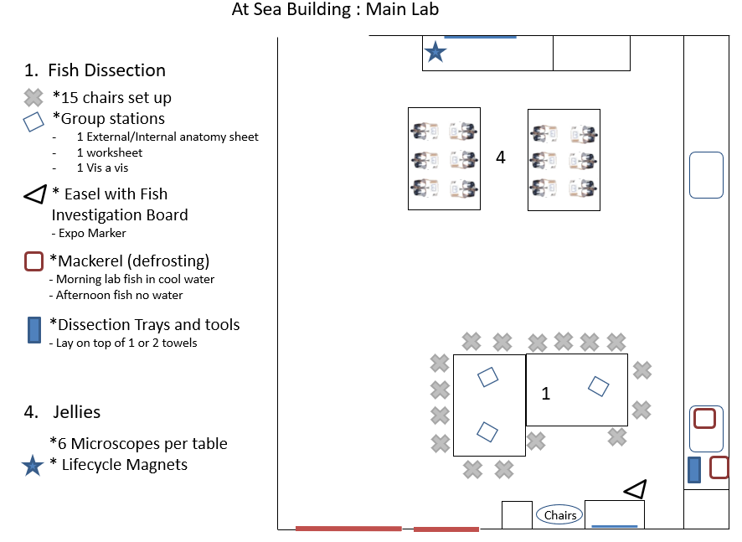
ROOM DIAGRAMS

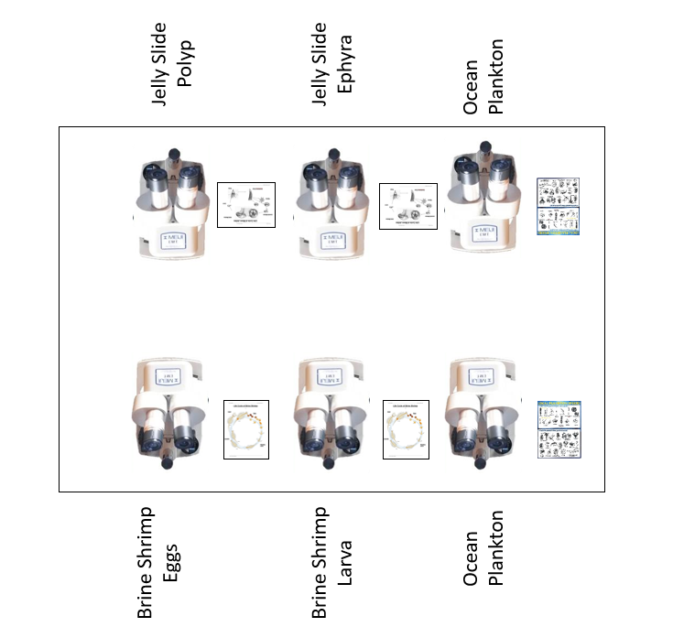

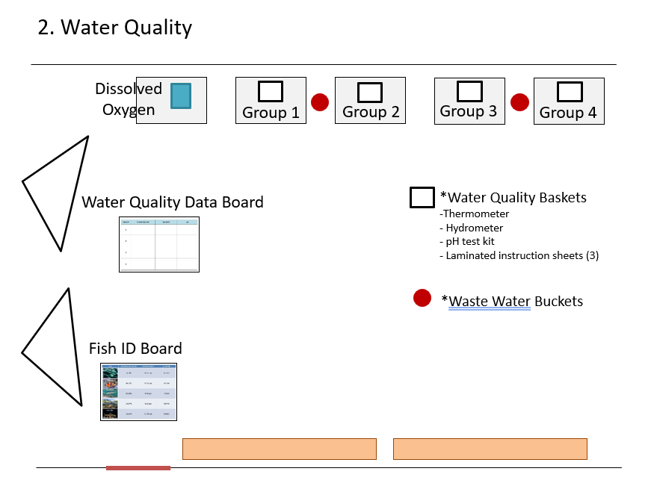

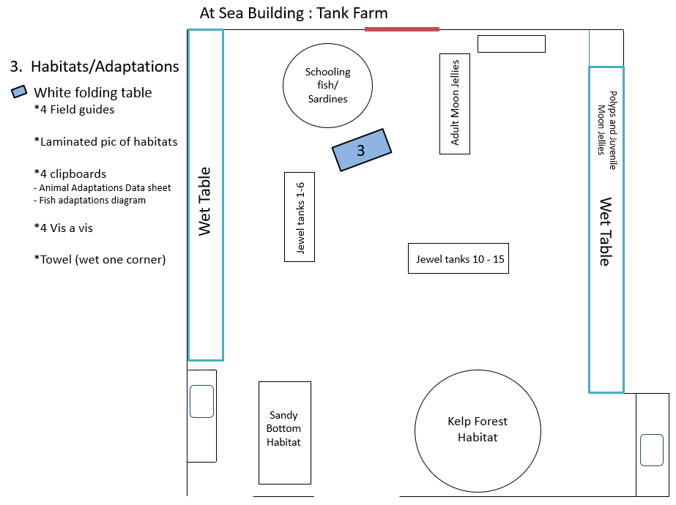
Stations (in order):
- Fish Dissection
  - Set up 10-15 chairs around tables. Pull out all dissection materials and set up next to the sink in At Sea. Pull dissection sheets out of the black cabinet and place on the tables for students to use.
  - There is a Fish Investigation board in Red Bin that may be useful for the station; place on the countertop under the TV monitor or on an easel stand.
  - Lay out newspaper and a disposable grocery bag (or two) for easy fish clean-up. Do NOT use the large trash can for throwing out fish – otherwise it will stink up the room unless we throw it out every single program!
  - Make sure the soap dispenser for the students has enough soap!

- Water Quality
  - Materials located in cabinet in At Sea. Transport to tables outside of Surf Science.
  - Frozen water bottles and sanitzed gloves are found in Sahm Kitchen.
  - Station may also be set up in Surf Science on blue lab tables, just outside of our Sand Lab (P-lab).

- Habitats and Adaptations
  - Set up one folding table in front of Schooling Fish Tank. Grab materials in At Sea.
  - Make sure to have a slightly damp towel to wipe off student worksheets.

- Life Cycles and Food Webs
  - Place 12 microscopes on two lab tables (six per table). Pull power outlet down from ceiling. Grab magnetic food chain cards and set down near the tall whiteboard next to the Tank Farm entrance.
  - Each table must have two different jelly life cycle stage slides, both brine shrimp eggs and hatchlings, and at least one sample of ocean plankton.
  - Turn off microscopes when not in use. Label any faulty microscopes with painter’s tape and what is wrong with it (if you know the issue).

STANDARDS

NGSS EXCERPTS DIRECTLY RELATED TO:
For more in-depth descriptions of these standards, please view at https://www.nextgenscience.org/
4-LS1-1 Construct an argument that plants and animals have internal and external structures that function to support survival, growth, behavior, and reproduction.
- [Clarification Statement: Examples of structures could include thorns, stems, roots, colored petals, heart, stomach, lung, brain, and skin.]

5-LS2-1 Describe a model to describe the movement of matter among plants, animals, decomposers, and the environment.
- [Clarification Statement: Emphasis is on the idea that matter that is not food (air, water, decomposed materials in soil) is changed by plants into matter that is food. Examples of systems could include organisms, ecosystems, and the Earth.]

5-ESS2-1 Develop a model using an example to describe ways the geosphere, biosphere, hydrosphere, and/or atmosphere interact.
- [Clarification Statement: Examples could include the influence of the ocean on ecosystems, landform shape, and climate; the influence of the atmosphere on landforms and ecosystems through weather and climate; and the influence of mountain ranges on winds and clouds in the atmosphere. The geosphere, hydrosphere, atmosphere, and biosphere are each a system.]

MS-LS1-3 Use argument supported by evidence for how the body is a system of interacting subsystems composed of groups of cells.
- [Clarification Statement: Emphasis is on the conceptual understanding that cells form tissues and tissues form organs specialized for particular body functions. Examples could include the interaction of subsystems within a system and the normal functioning of those systems.]

MS-LS1-4 Use arguments based on empirical evidence and scientific reasoning to support an explanation for how characteristic animal behaviors and specialized plant structures affect the probability of successful reproduction of animals and plants respectively.
- [Clarification Statement: Examples of behaviors that affect the probability of animal reproduction could include nest building to protect young from cold, herding of animals to protect young from predators, and vocalization of animals and colorful plumage to attract mates for breeding. Examples of animal behaviors that affect the probability of plant reproduction could include transferring pollen or seeds and creating conditions for seed germination and growth. Examples of plant structures could include bright flowers attracting butterflies that transfer pollen, flower nectar and odors that attract insects that transfer pollen, and hard shells on nuts that squirrels bury.]

MS-LS1-6 Construct a scientific explanation based on evidence for the role of photosynthesis in the cycling of matter and flow of energy into and out of organisms.
- [Clarification Statement: Emphasis is on tracing movement of matter and flow of energy.]
MS-LS2-1 Analyze and interpret data to provide evidence for the effects of resource availability on organisms and populations of organisms in an ecosystem.
- [Clarification Statement: Emphasis is on cause and effect relationships between resources and growth of individual organisms and the numbers of organisms in ecosystems during periods of abundant and scarce resources.]

MS-LS2-2 Construct an explanation that predicts patterns of interactions among organisms across multiple ecosystems.
- [Clarification Statement: Emphasis is on predicting consistent patterns of interactions in different ecosystems in terms of the relationships among and between organisms and abiotic components of ecosystems. Examples of types of interactions could include competitive, predatory, and mutually beneficial.]

MS-LS2-3 Develop a model to describe the cycling of matter and flow of energy among living and nonliving parts of an ecosystem.
- [Clarification Statement: Emphasis is on describing the conservation of matter and flow of energy into and out of various ecosystems, and on defining the boundaries of the system.]

